VibeShift



PROJECT SUPERVISOR: Mr. Syed Zain Ul-Hassan
PROJECT CO-SUPERVISOR: Ms Sania Urooj

PROJECT TEAM
Mehreen Saghar 22K-4071
Insiya Fakharuddin 22K-4103
Fatima Zafar 22K-4124

SUBMISSION DATE
December 11, 2025

Table of Content

Abstract 3
1. Introduction 3
1.1. Purpose of Document 3
1.2. Intended Audience 3
1.3. Document Convention 4
1.4. Project Background 4
1.5. Project Overview 5
1.6. Scope 5
1.6.1. Features Included 5
1.6.2. Features that will not be included 6
2. Market GAP 6
3. Software Requirement Specifications (SRS) 7-32
4. Software Design Specifications (SDS) 32-61
5. FYP II Deliverables 62
6. Timeline 63
7. Outputs of the Product 64
8. Conclusion 65
9. References 66

Abstract

VibeShift is an intelligent audio-processing and music-transformation system designed to simplify and democratize music editing for everyday users, students, and content creators. Traditional music production tools require substantial domain knowledge, manual effort, and expensive software licenses, making advanced music manipulation inaccessible for many. VibeShift addresses this gap by introducing two core features: Music Stemming and Genre Transformation.
The Music Stemming module allows users to upload an audio file and automatically extract its primary musical components—vocals, drums, bass, and accompanying instruments. Beyond separation, users can add or remove stems, modify pitch, and adjust timbre, enabling flexible experimentation without requiring professional editing expertise. The Genre Transformation feature, powered by machine learning and generative AI, allows users to convert a song from one musical genre to another by learning stylistic attributes from reference datasets. This opens possibilities for creative re-arrangements, remixing, and artistic exploration.
This FYP-I report outlines the project's vision, technical motivation, requirements, system design concept, and deliverables. It covers the background, market gap, use-case modeling, UI designs, timeline, risk assessment, and planned implementation pipeline

- Introduction

  - Purpose of Document
This progress report provides a comprehensive overview of our Final Year Project titled “VibeShift”. It documents all progress made during the FYP-I phase, including background research, project objectives, system scope, planned functionalities, and development approach. Additionally, this document outlines the technical direction, design considerations, project limitations, UI concepts, and identified market gaps.
The purpose of this report is to ensure that supervisors, evaluators, and future developers have a clear, structured understanding of the system being developed and the work completed to date.

  - Intended Audience
The intended audience of this document includes:
- FYP Supervisors overseeing the project and evaluating its progress.
- Internal and External Examiners involved in the review and assessment of the system.
- Future Developers who may continue enhancing or extending the system after the completion of the degree.
- Researchers and Students interested in studying or further developing music processing and audio transformation systems.
- Musicians, Creators, and Audio Engineers looking for a simplified platform for audio stem manipulation and genre transformation.

  - Document Convention

To maintain uniformity and readability, the following formatting conventions have been followed throughout this report:
- Font Style: Times New Roman
- Heading Font Size: 18
- Subheading #1 Font Size: 16
- Subheading #2 Font Size: 14
- Subheading #3 Font Size: 12
- Subheading #4 Font Size: 10
- Text Font Size: 12
- Line Spacing: 1.15
These conventions align with the Department of Computer Science FYP documentation standards.

  - Project Background

Music creation, editing, and transformation have become increasingly relevant across industries such as entertainment, content creation, gaming, social media, advertising, and independent artistry. However, high-quality music production tools remain expensive, complex, and inaccessible to beginners.
Most users struggle with tasks such as:
- Isolating instruments from a mixed audio track
- Adjusting pitch or timbre without quality loss
- Editing stems in a simplified workspace
- Transforming a song from one genre to another
Existing software such as FL Studio, Ableton, and Logic Pro are feature-rich but require extensive knowledge, training, and financial investment. Open-source tools, while powerful, lack proper interfaces and require technical coding expertise.
To address this gap, VibeShift is introduced as an intelligent, beginner-friendly, and highly interactive audio processing system capable of:
- Music Stemming (separating a track into vocals, drums, bass, etc.)
- Editing Stems (adding/removing stems, pitch/timbre changes)
- Genre Transformation using machine learning (Phase II)
The system provides an intuitive workspace where users can manipulate audio creatively without requiring deep professional experience or expensive tools.

  - Project Overview

VibeShift is designed as a desktop/web-based audio processing system aimed at musicians, students, content creators, and hobbyists who want to edit or transform music without complex tools. While numerous audio editing platforms exist, they fail to combine stem separation, real-time editing, and genre conversion in a single user-friendly application.

The platform offers:
- A clean and easy-to-navigate interface
- Automated processing powered by DSP and AI
- Real-time audio previews
- Editable stems (mute, solo, adjust pitch, modify timbre)
- A scalable backend for future AI-based genre transformation
- Export options for modified audio

In Phase I (FYP-I), the focus is on:
- Researching DSP and ML models
- UI/UX design
- Implementing the stem separation and editing modules
- Establishing a proper software architecture
- Preparing SRS and SDS documents

In Phase II (FYP-II), the full genre transformation pipeline and advanced editing systems will be implemented.

  - Scope

Our project, VibeShift, provides a platform where users can upload, edit, manipulate, and transform audio using intelligent tools. This system will remain free of cost and accessible to beginners and intermediate creators.

1.6.1 Features Included
Features for Admin
- Attractive and responsive admin dashboard
- View uploaded songs and processed stems
- Approve/disapprove user uploads (optional moderation)
- Monitor system logs (processing time, errors, model performance)
- Remove inappropriate or corrupted audio submissions
- Backend controls for machine learning model configuration

Features for Users
- Simple, attractive, and user-friendly interface
- Upload audio in MP3/WAV formats
- Automatic stem separation (vocals, drums, bass, instruments)
- Real-time waveform visualization
- Adjust pitch and timbre
- Mute/solo stems
- Add or remove stems
- Export edited audio
- Genre transformation (Phase II)
- Login/Signup for personalized workspace
- Save projects and revisit history
- Download processed stems individually
- Receive audio quality warnings (based on DSP analysis)

Features for Guest Users
- Explore demo features
- View example processed stems
- Access limited previews of the system
- No login required for basic trial mode

1.6.2 Features NOT Included
- Video editing or processing
- Audio-to-video synchronization features
- Real-time voice calling or messaging
- Live collaboration between users
- Full AI-based genre transformation (planned for FYP-II)

- Market GAP

Despite various audio manipulation tools in the market, several gaps remain unaddressed:

● Lack of a unified platform
No existing tool combines stem separation, editing, and AI-based genre transformation in one environment.

● Accessibility barriers
Most professional tools are too expensive for students, new creators, and hobbyists.

● Complex user experience
Users require technical knowledge to navigate traditional DAWs or command-line ML tools.

● No beginner-friendly audio editing environment
Existing software prioritizes professional controls over simplicity.

● Missing automated quality control
Unlike VibeShift, no system currently:
- Analyzes audio quality
- Warns users about clipping, noise, or distortion
- Removes unwanted frequencies automatically

● No automated inappropriate audio detection
- Harmful content
- Copyrighted materials
- Extremely low-quality uploads

FYP II Deliverables
• Develop and train advanced machine learning models (CNN / Transformers / GANs) for music style and genre transfer.
• Integrate all system components—frontend, backend APIs, and machine learning services—into a unified, fully functional platform.
• Conduct extensive unit testing, integration testing, and system-wide debugging to ensure stability and reliability.
• Optimize system performance by reducing processing latency, improving model inference speed, and refining audio output quality.
• Perform user testing and gather feedback from target users to validate usability, accuracy, and overall system experience.
• Execute final acceptance testing to ensure system completeness, adherence to requirements, and overall readiness for deployment.
• Prepare and submit the complete FYP-II documentation, including final report, technical manuals, and demonstration materials.

FYP II Timeline

Month | Tasks / Activities
Month 5 | • Develop and train ML models (CNN / Transformer / GAN) for music genre/style transfer.  • Prepare training datasets and perform preprocessing.  • Integrate pretrained models for testing and baseline comparisons.  • Begin connecting ML services with backend APIs.
Month 6 | • Fully integrate frontend, backend, and machine learning modules into a unified platform.  • Implement real-time audio preview and stem-editing improvements.  • Debug major integration issues and refine architecture.  • Start system-wide feature testing.
Month 7 | • Conduct unit testing, integration testing, and stress testing.  • Optimize model inference speed and reduce system latency.  • Improve UI responsiveness and audio processing quality.  • Begin user testing with selected participants.
Month 8 | • Gather user feedback and perform user acceptance testing (UAT).  • Final refinements, performance tuning, and bug fixes.  • Complete final documentation (FYP-II report, user manual, technical manual).  • Prepare project for final submission and presentation.

- Outputs of the Product

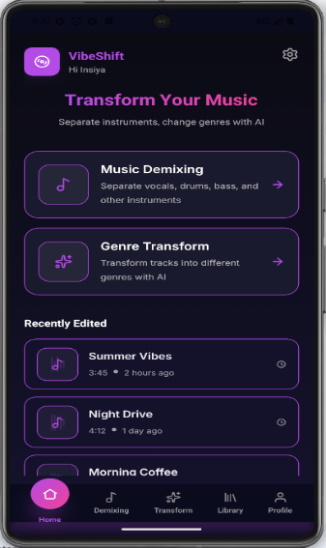 | 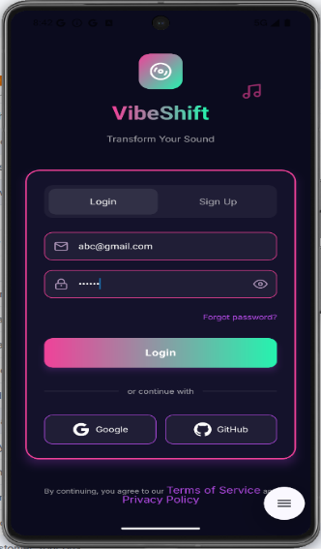 |  | 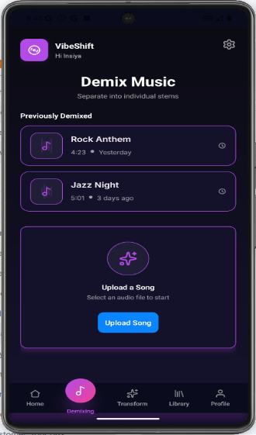 |  | 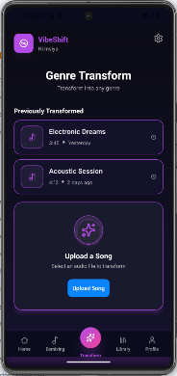
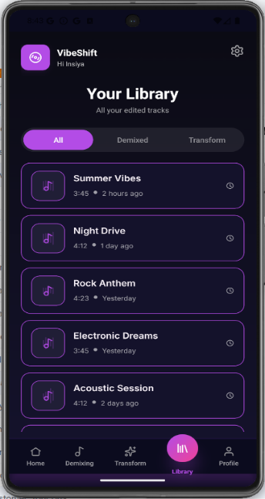 | 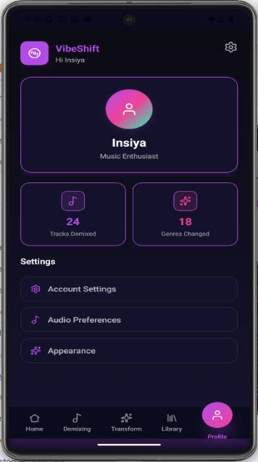 |  | 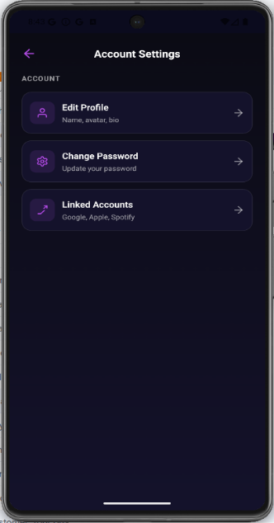

- Conclusion
The development of VibeShift marks an important step toward making advanced audio processing and creative music editing more accessible to everyday users, students, and emerging content creators. Traditional music production platforms require both technical expertise and expensive software, creating a barrier for individuals who want to explore music manipulation and creative expression. Through intelligent music stemming, editable audio components, and a scalable architecture for AI-driven genre transformation, VibeShift aims to bridge this gap by providing an intuitive, user-friendly, and cost-free environment.
During FYP-I, the project focused on research, requirement gathering, system planning, and the development of core features such as stem extraction, editing tools, and conceptual UI design. The creation of SRS and SDS documents has helped establish a strong foundation for implementation in the next phase. The identified market gap reinforces the need for an integrated platform that combines DSP techniques, machine learning, and an interactive interface—something currently lacking in the industry.
Moving into FYP-II, the focus will shift toward full system integration, machine learning model training, improved performance, and the implementation of AI-powered genre transformation. Additional emphasis will be placed on testing, optimization, user feedback, and final submission. Overall, VibeShift establishes a promising trajectory toward becoming a comprehensive and innovative tool for music analysis, editing, and creative transformation.

- References
[1] A. Défossez, N. Usunier, L. Bottou, and F. Bach, “Demucs: Music source separation with transformers,” arXiv preprint arXiv:2111.03600, 2021.
[2] R. Hennequin, A. Khlif, F. Voituret, and M. Moussallam, “Spleeter: A fast and state-of-the-art music source separation tool,” in Proc. Int. Soc. Music Information Retrieval Conf. (ISMIR), 2020.
[3] J. Foote, “Automatic audio genre classification,” in Proc. ACM Int. Multimedia Conf., 1997, pp. 397–400.
[4] C. Donahue, J. McAuley, and M. Puckette, “Adversarial audio synthesis,” in Proc. Int. Conf. Learning Representations (ICLR), 2019.
[5] Z. Rafii and B. Pardo, “A music/voice separation system based on the similarity matrix,” in Proc. IEEE Int. Conf. Acoustics, Speech, Signal Process. (ICASSP), 2013, pp. 41–44.
[6] A. Vaswani et al., “Attention Is All You Need,” in Advances in Neural Information Processing Systems (NeurIPS), 2017.
[7] I. Goodfellow et al., “Generative Adversarial Nets,” in Advances in Neural Information Processing Systems, 2014.
[8] B. McFee et al., “librosa: Audio and Music Signal Analysis in Python,” in Proc. Python in Science Conference, 2015, pp. 18–25.
[9] K. Choi, G. Fazekas, M. Sandler, and K. Cho, “Convolutional Recurrent Neural Networks for Music Classification,” in IEEE ICASSP, 2017.
[10] J. N. Godwin, R. Jaiswal, and J. J. Korhonen, “Music Style Transfer: A Survey,” ACM Computing Surveys, vol. 55, no. 9, 2022.
[11] E. M. Grais, H. Wierstorf, and M. D. Plumbley, “Source separation driven audio enhancement using deep neural networks,” IEEE Signal Processing Letters, vol. 25, 2018.
[12] OpenAI, “Generative AI and Audio Processing Capabilities,” Technical Documentation, 2023.
[13] J. Engel et al., “Neural Audio Synthesis of Musical Notes with WaveNet Autoencoders,” in Proc. Int. Conf. Machine Learning (ICML), 2017.
[14] S. Stevens, Introduction to Digital Signal Processing, McGraw-Hill Education, 2019.
[15] Nielsen Norman Group, “10 Usability Heuristics for User Interface Design,” 2020.
[16] Flutter Documentation, “Building Cross-Platform Applications,” 2024.

